COB Editor User Manual
by Peter Wong and Jie Bao

Installation

Prerequisites
The COB Editor relies on the following pieces of software to run properly:
- Java Runtime Enviroment (JRE) 1.5 and above
- PostgresSQL 8.0
  - Standard PostgresSQL installation
  - JDBC PostgresSQL drivers

[Fill in later]

Running the COB Editor

[Fill in later]

Creating a new COB Ontology Server

Prerequisite Knowledge
- Database Address (ex. localhost, 127.142.123.12, etc.)
- Type of Database (PostgresSQL, MySQL, Oracle)
- Username and Password for Database access

Step 1 Choosing an Ontology

With the mouse, select from the menu bar Setting → Create Ontology

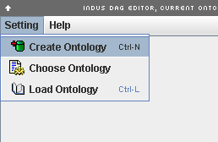

Step 2 Clicking next…

Click the “Next” Button to continue the process.

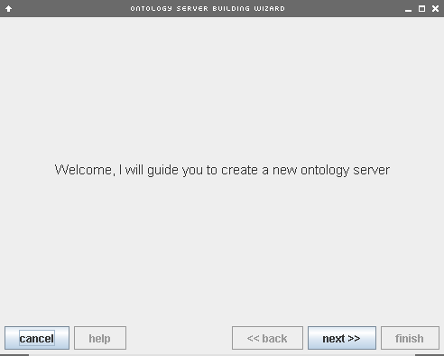

Step 3 Specifying Server Information

To create a new ontology, the necessary information about the database hosting the ontology, and username, password to access that database must be specified.

Host – The address that the database resides at
Default Table – The default table’s name
User - The username allowed to create users and tables on the database
Password – The password for that username.

Click the “Next” button to continue the process.

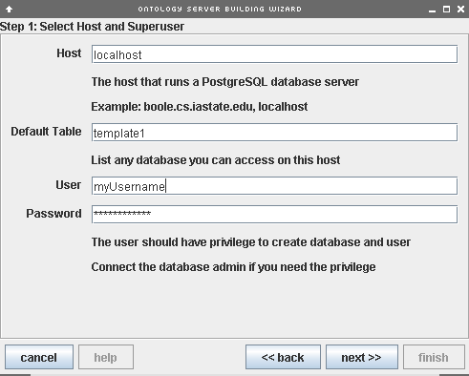

Step 4 Specifying Server Information

This page of the setup, the Ontology Server Name and the Public Access Settings are specified.

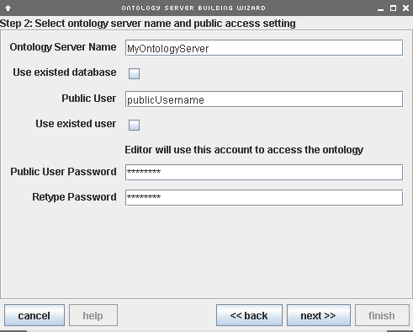
Connecting to a COB Ontology Server

Prerequisite Knowledge
- Ontology Server Address (ex. localhost, 127.142.123.12, etc.)
- Type of Server (PostgresSQL, MySQL, Oracle)
- Username and Password for access

Step 1 Choosing an Ontology

With the mouse, select from the menu bar Setting → Choose Ontology

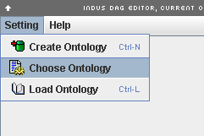

Step 2 Specifying Server Information

To access a particular ontology, the necessary information to connect to the database hosting the ontology, and username, password to access that database must be specified. The Ontology Server Setting dialogue box will popup after completing Step 1. Click the “New” button to start specifying a new ontology to connect to. Continue by filling each field.

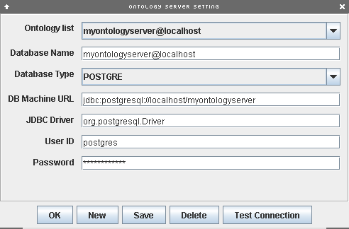
Step 2 Specifying Server Information (continued…)

You can check the validity of the supplied information by clicking the “Test Connection”. If the information supplied is correct, a dialogue box similar to the following will result.

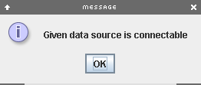

Click the “Save” button to save the server information for further use and then click the “OK” button.

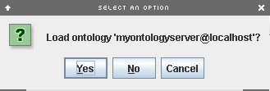

You will presented with a final dialogue box to reconfirm the ontology being loaded. Click the “Yes” button to finish the process.

Editing an [Ontology]

[Exclamation Logo] Before editing an Ontology, you must first be connected to an Ontology Server. For more information about connecting see Connecting to a COB Ontology Server.

Overall Editor Layout

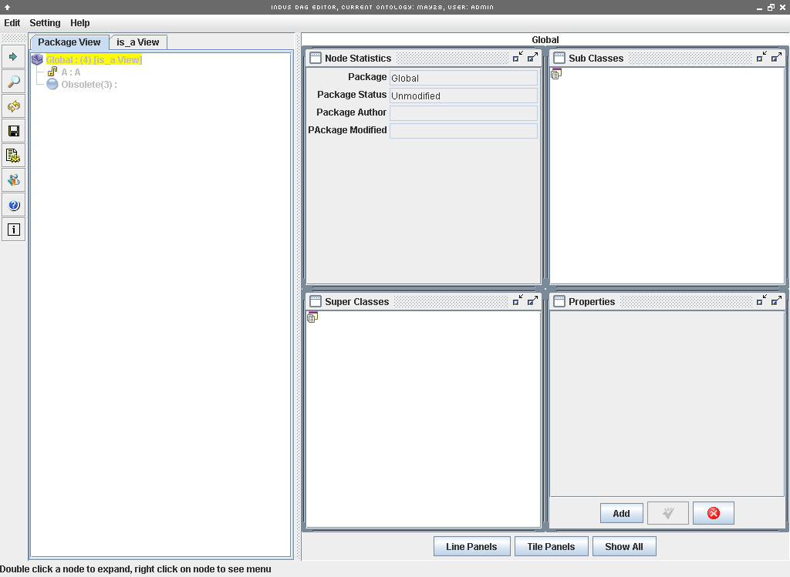

The editor is made up of 4 parts: Package View, Contextual Information, Quick Options, and Menu Bar. These parts are identified below.
Menu Bar

Package/Relation View
Contextual Information
Quick
Options

Menu Bar
[Provides options for managing Ontology Servers]

Quick Options
Expand
Expands the currently selected Package or Term, to allow you to see any Subterms or Subpackages that exist.

Find
Allows the user to search for particular Package or Term in the current Ontology Server.

Refresh
Reloads all packages and terms from the current Ontology Server. If any changes have been made since loading the server or the last save, this option will first ask whether to save or not.


Expand
Find
Refresh

Quick Options (continued…)
Save
Saves the any changes made to the Ontology Server since loading the server or last save.

Choose
Allows the user to load another Ontology Server.

Editing Users
Allows the user to see any other users that are currently editing the current Ontology Server.

Help
Provides useful information.

Information
Provides useful information.

Save
Choose
Editing Users
Help
Information

Contextual Information
These for panels provide information specific information for what is currently being selected in the Package/Relation View.
Node Statistics
Provides the following information about the selected Package or Term:
- Name
- Status
- Author
- Date Last Modified

Sub Classes
Lists all Subpackage or Subterms that are children to the selected package or term.

Properties
Provides any miscellaneous information associated with the selected Package or Term.

Super Classes
Lists all Super Package or Super Terms that are parent to the selected package or term.

Package/Relation View
This view provides a tree view of the Packages, Terms, and Relationships that make up an Ontology Server. This tree view representation of an ontology is made of Package or Term nodes. Nodes can be distinguished by the icon and text representing a node. The following are examples of different nodes.
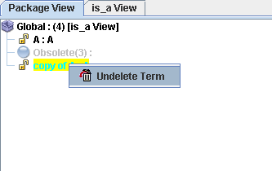
Unloaded Package

Loaded Package displaying “Is a” relationships of children Packages and Terms, made up of 4 Packages and/or Terms.

Term with the name “B”

Ancestor Term with the name “A”.

Deleted Term with the name “A”

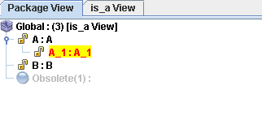
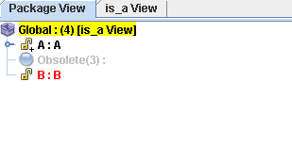
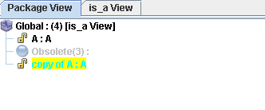

Need to add “loaded, but uneditable” Package

Context Menus
Each type of node has a contextual menu with node specific options. A context menu for a node can be seen when right clicking on that node. The following are context menus for each type of node and description of the options making up the context menu.

Unloaded Package
TODO

Unloaded Package
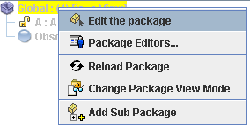
Edit the Package
Allows the user to edit the package.
Package Editors
???
Reload Package
Reloads all sub packages and terms of the package.
Change Package View Mode
Allow the user to change what relational view the package is viewed in.
Add Sub Package
Adds a sub package to the package.

Term
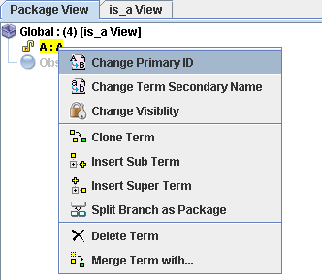
Change Primary ID
Allows the user to change the Primary ID of the term.
Change Term Secondary Name
Allows the user to change the Secondary Name of the term.
Change Visibility
Allows the user to changes the visibility of the term to either public, private, or protected.
Clone Term
Clones the term.
Insert Sub Term
Allows the user to add Subterm to the term.

Insert Super Term
Allows the user to add Super term to the term.
Split Branch as Package
???
Delete Term
Deletes the term from the current package.
Merge Term with..
???

Deleted Term
Undelete Term
Undeletes the term from the current package.

Basic Operations
In this section we will spend some time to describe in full how some basic ontology operations are performed.

Adding a Sub Term to a Term

Step 1 Choosing Term to add Sub Term

Right click the term that you want to add a sub term. The context menu for a term will be displayed (as shown in the above figure). Select the “Insert Sub Term” option from the context menu.

Step 2 Choosing Term to add Sub Term

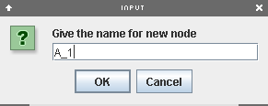
A dialogue box should appear, asking what the new Subterm’s name. An automatically generated name will be given by default. Type in the name of new Subterm’s and click the “OK” button.

The new Sub term will show up under its parent term. The new Sub Term will initially be colored red, to signify that it is a new addition since the last time the ontology was saved or loaded.

